

Faculty of Engineering and Technology

School of Computer Science

2022-2023

A

Project Report

ON

**“Heart Failure Prediction”**

**BY**

**ROHIT DARUNKAR : 1132220719**

**In Partial fulfilment Of**

**Master Of Science(Msc. Computer Science)**

**Dr. Vishwanath Karad MIT World Peace University**



School of Computer Science

CERTIFICATE

This is to certify that, ROHIT DARUNKAR student of MSc(Computer Science)

Semester 1 has successfully / partially completed MINI Project in partial fulfilment of M.Sc. Computer Science under Dr. Vishwanath Karad MIT World Peace University, for the academic year 2022-2023.

Ms. Devyani Kamble Mr. Rahul Karad

Course Teacher Head of the School

Date 02/ 12 / 2022



Acknowledgement

Place: MIT-WPU, Pune.

Date: 02-12-2022

I would like to express my sincere thanks to Ms. Devyani Kamble for her valuable guidance and support in completing my project. I would also like to express my gratitude towards our principal Mr Rahul Karad for giving me this great opportunity to do a project on Loan Approval System. Without their support and suggestions, this project would not have been completed.

ROHIT DARUNKAR

DECLARATION

### I hereby declare that the project entitled “Heart Failure Prediction” submitted to the MIT World Peace University, is a record or original work done by me under the guidance of Mrs. Devyani Kamble , Program Head, Department of Computer Science, MIT World Peace University, and this project work is submitted in the partial fulfilment of the requirements for the award of the degree of MS.c. Computer Science. The results embodied in this thesis have not been submitted to any other University or Institute for the award of any degree or diploma.

**ROHIT DARUNKAR : 1132220719**

**Project Report Text Properties**

1. **Font : Calibri(Body)**
2. **Font Size : Headings – 14 , Body – 12**
3. **Spacing : 1.0**

**INDEX**

| Sr.No | Contents | Page No. |
| --- | --- | --- |
| Chapter 1 | Introduction   * 1. Problem Statement   2. Description of Data Set   3. Objectives of System   4. Module List |  |
| Chapter 2 | Analysis And Design  2.1 UML Diagram (Flow Chart, Class Diagram, Use Case Diagram, Sequence Diagram, Activity Diagram, component Diagram, deployment Diagram etc)  2.2 Screenshots |  |
| Chapter 3 | User Manual  3.1 User Manual |  |
| Chapter 4 | Conclusion  4.1 Limitations And drawbacks  4.2 Future Enhancement  4.3 References and Bibliography |  |

**CHAPTER 1 : INTRODUCTION**

1.1 - PROBLEM STATEMENT :

The major challenge in heart disease is its detection. There are instruments available which can predict heart disease but either they are expensive or are not efficient to calculate the chance of heart disease in humans. Early detection of cardiac diseases can decrease the mortality rate and overall complications. However, it is not possible to monitor patients every day in all cases accurately and consultation of a patient for 24 hours by a doctor is not available since it requires more patience, time and expertise. Since we have a good amount of data in today’s world, we can use various machine learning algorithms to analyze the data for hidden patterns. The hidden patterns can be used for health diagnosis in medicinal data.

1.2 - DESCRIPTION OF DATASET:

Cardiovascular diseases (CVDs) are the number 1 cause of death globally, taking an estimated 17.9 million lives each year, which accounts for 31% of all deaths worldwide. Heart failure is a common event caused by CVDs and this dataset contains 12 features that can be used to predict mortality by heart failure. Most cardiovascular diseases can be prevented by addressing behavioural risk factors such as tobacco use, unhealthy diet and obesity, physical inactivity and harmful use of alcohol using population-wide strategies. People with cardiovascular disease or who are at high cardiovascular risk (due to the presence of one or more risk factors such as hypertension, diabetes, hyperlipidaemia or already established disease) need early detection and management wherein a machine learning model can be of great help.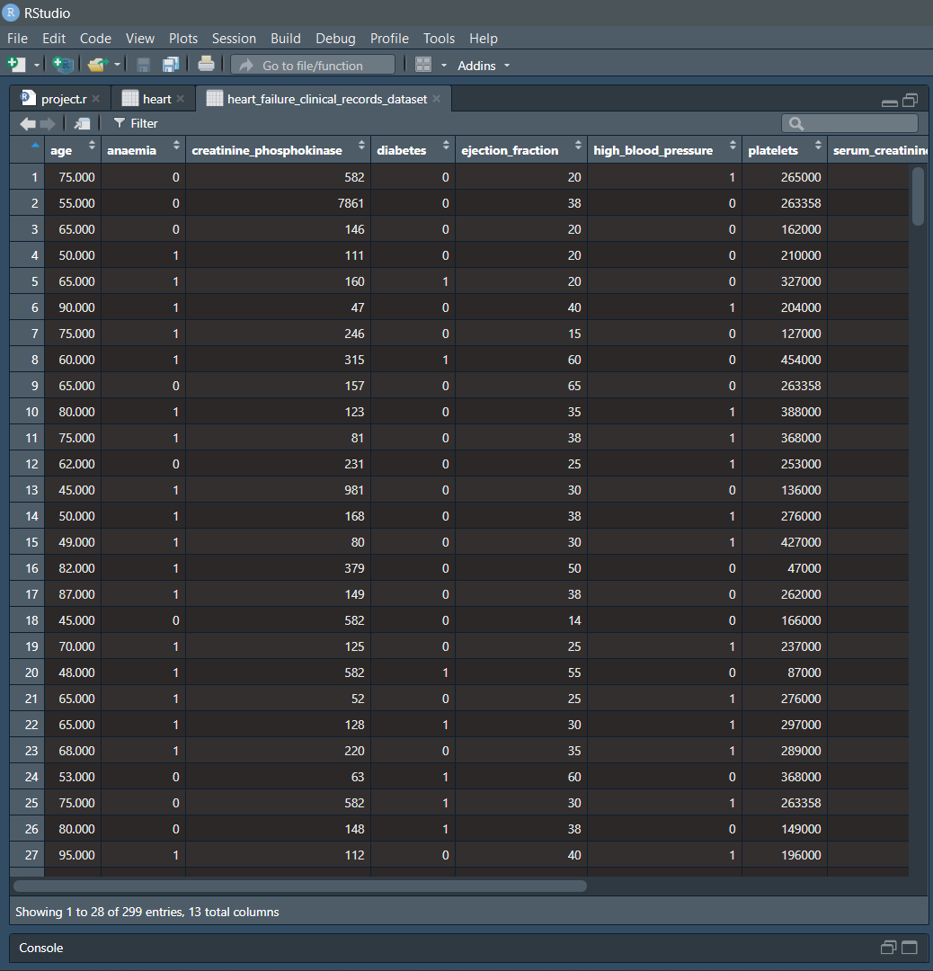

1.3 - OBJECTIVE OF SYSTEM:

The important purpose of this research is the development of a cardiac prediction system. The system can discover and extract disease-related hidden knowledge from past cardiac records. A heart disease prediction system aims to use data mining techniques on medical datasets to help predict heart disease.The main objective of developing this project are:

1. To develop machine learning model to predict future possibility of heart disease by

implementing Logistic Regression.

2. To determine significant risk factors based on medical dataset which may lead to heart

disease.

3. To analyze feature selection methods and understand their working principle.

1.4 - MODULE LIST:

1. Data Preprocessing

2. Model Implementation

3. Data Visualisation

**CHAPTER 2: ANALYSIS AND DESIGN**

2.1 UML DIAGRAMS

1. FLOW CHART:

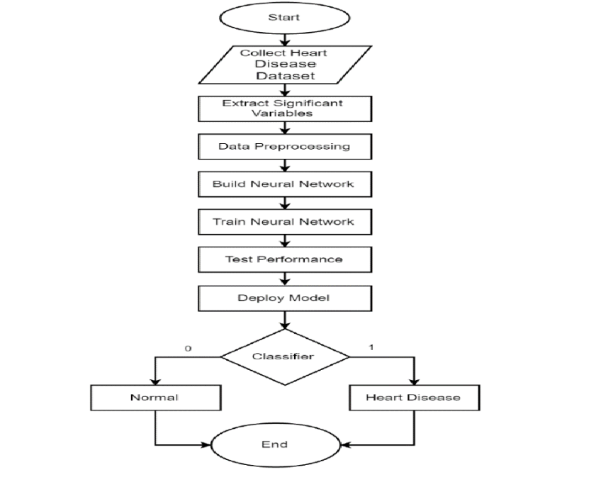

1. CLASS DIAGRAM:

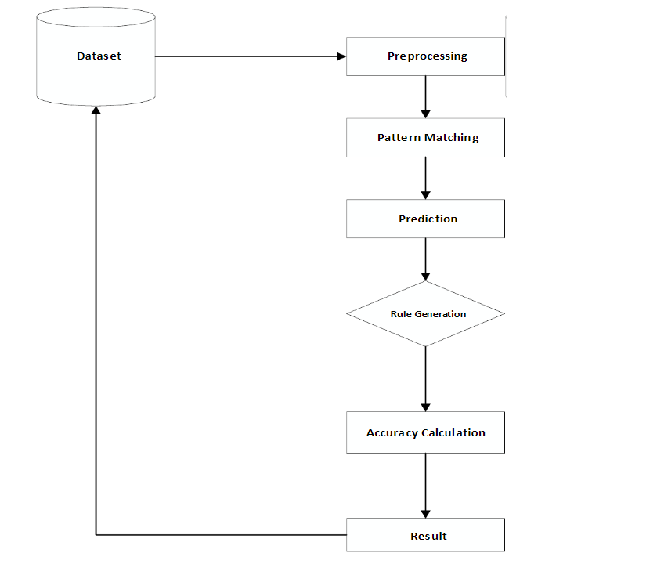

3) PROJECT MODEL:

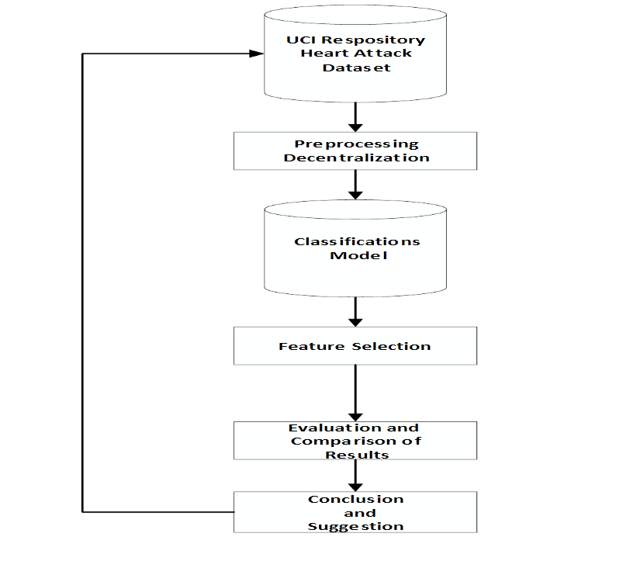

CHAPTER 2.2 - SCREENSHOTS:

1. BAR PLOT :

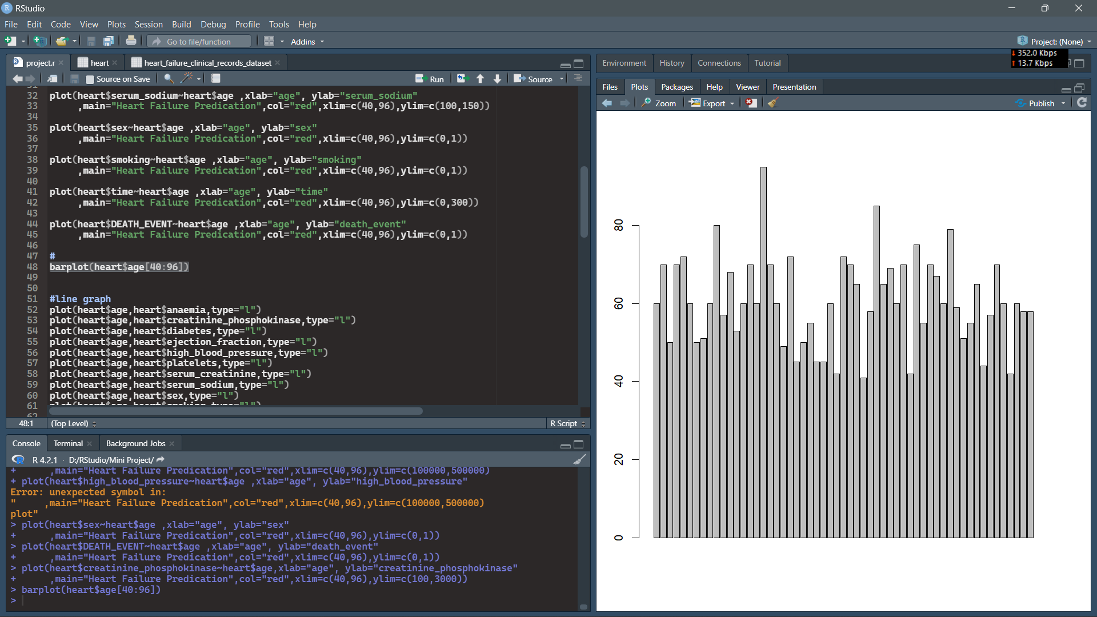

1. HISTOGRAM DIAGRAM (1) :

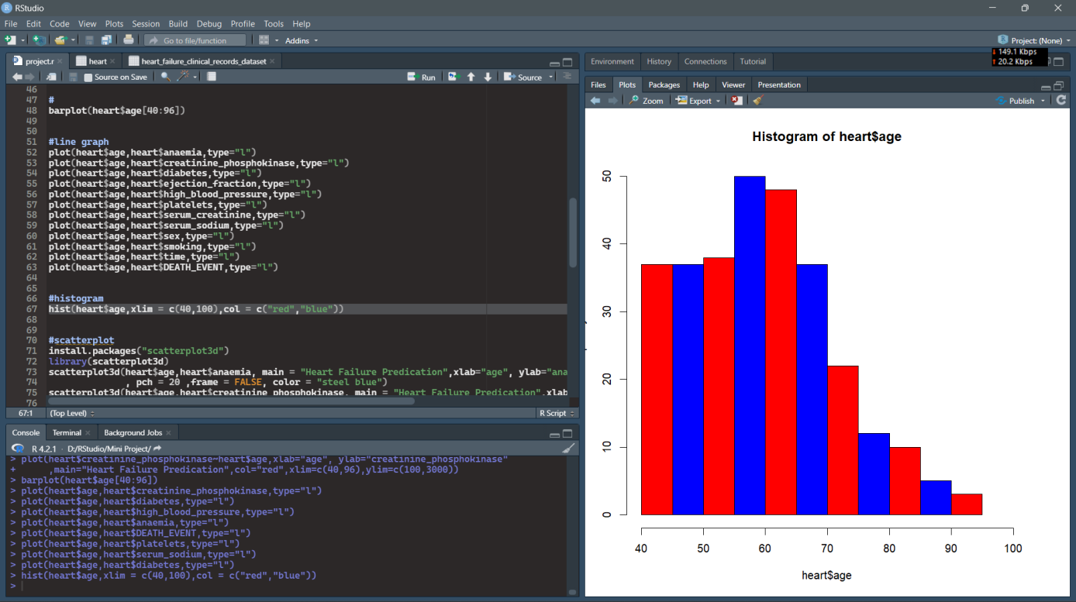

2.HISTOGRAM DIAGRAM(2) :

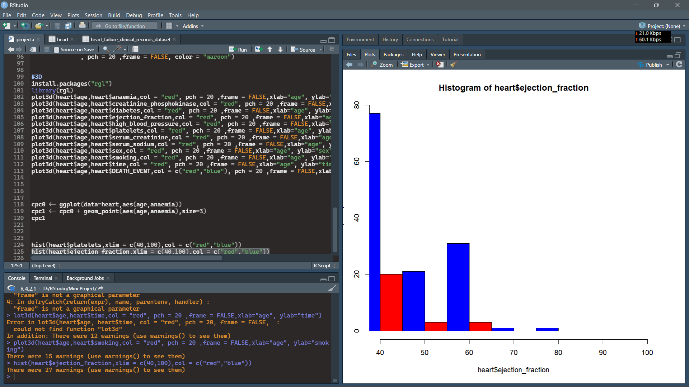

1. LINE GRAPH(1) :

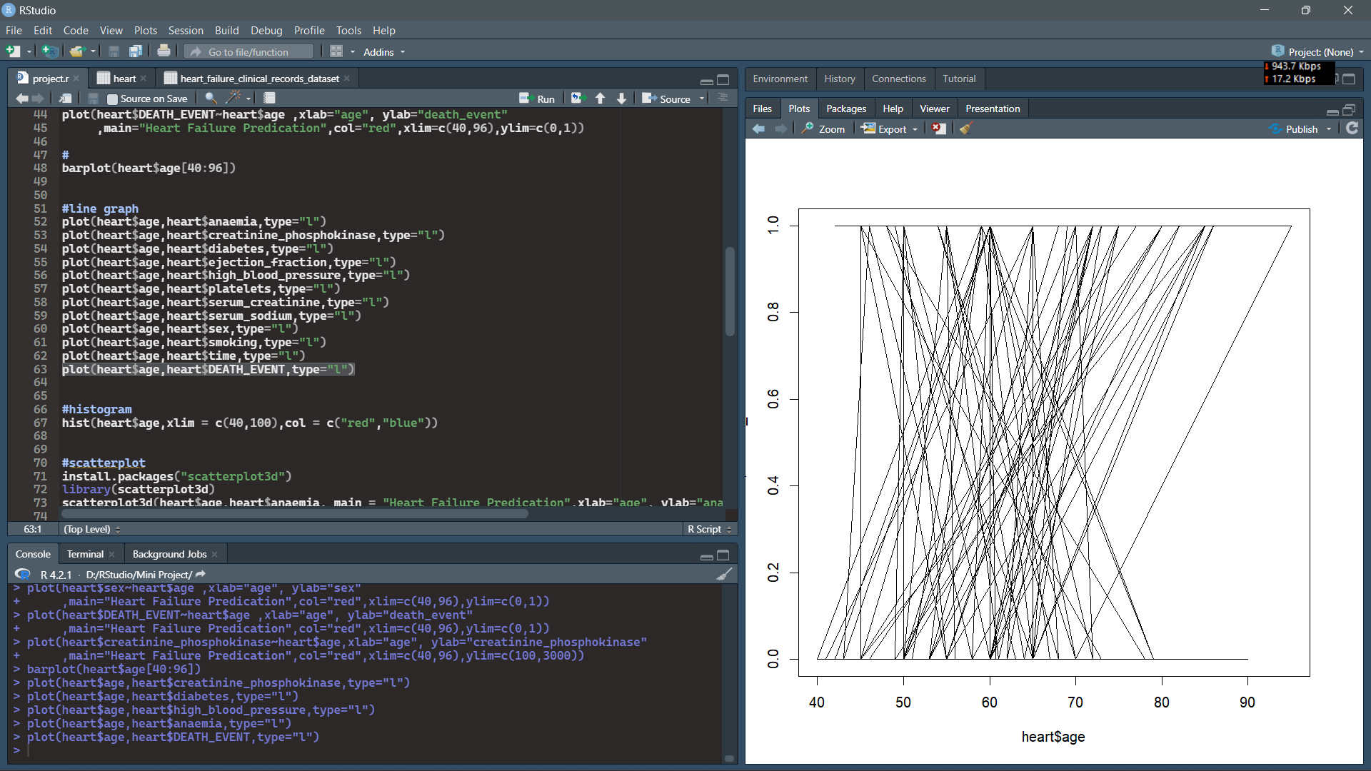

3. LINE GRAPH(2) :

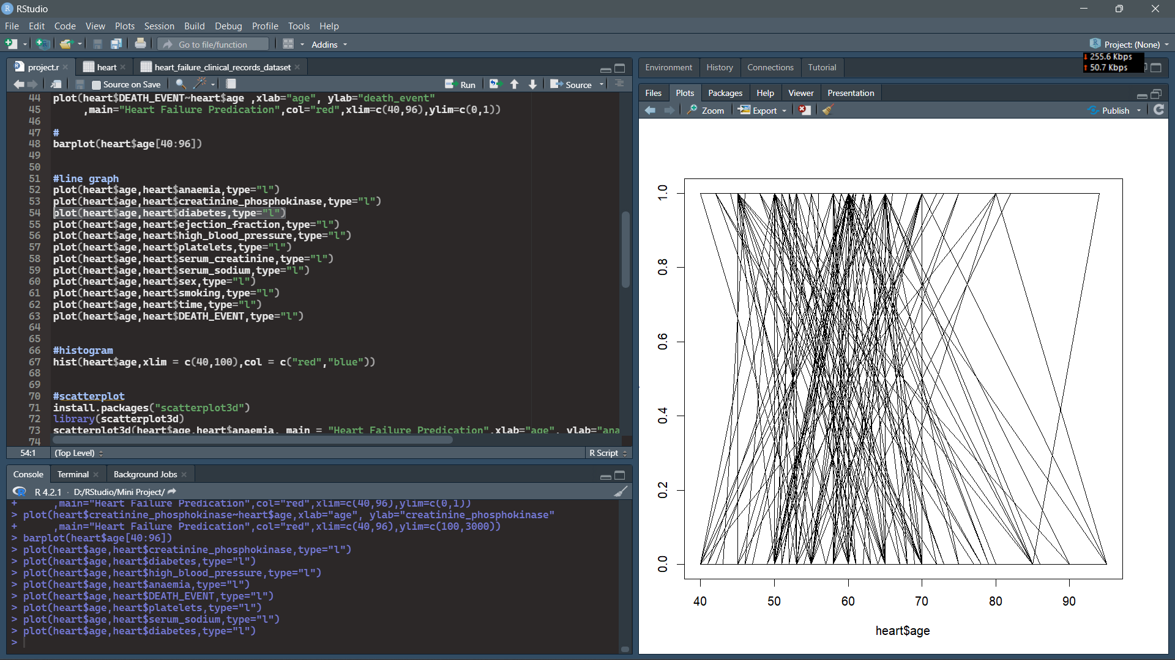

1. PLOT DIAGRAM(1) :

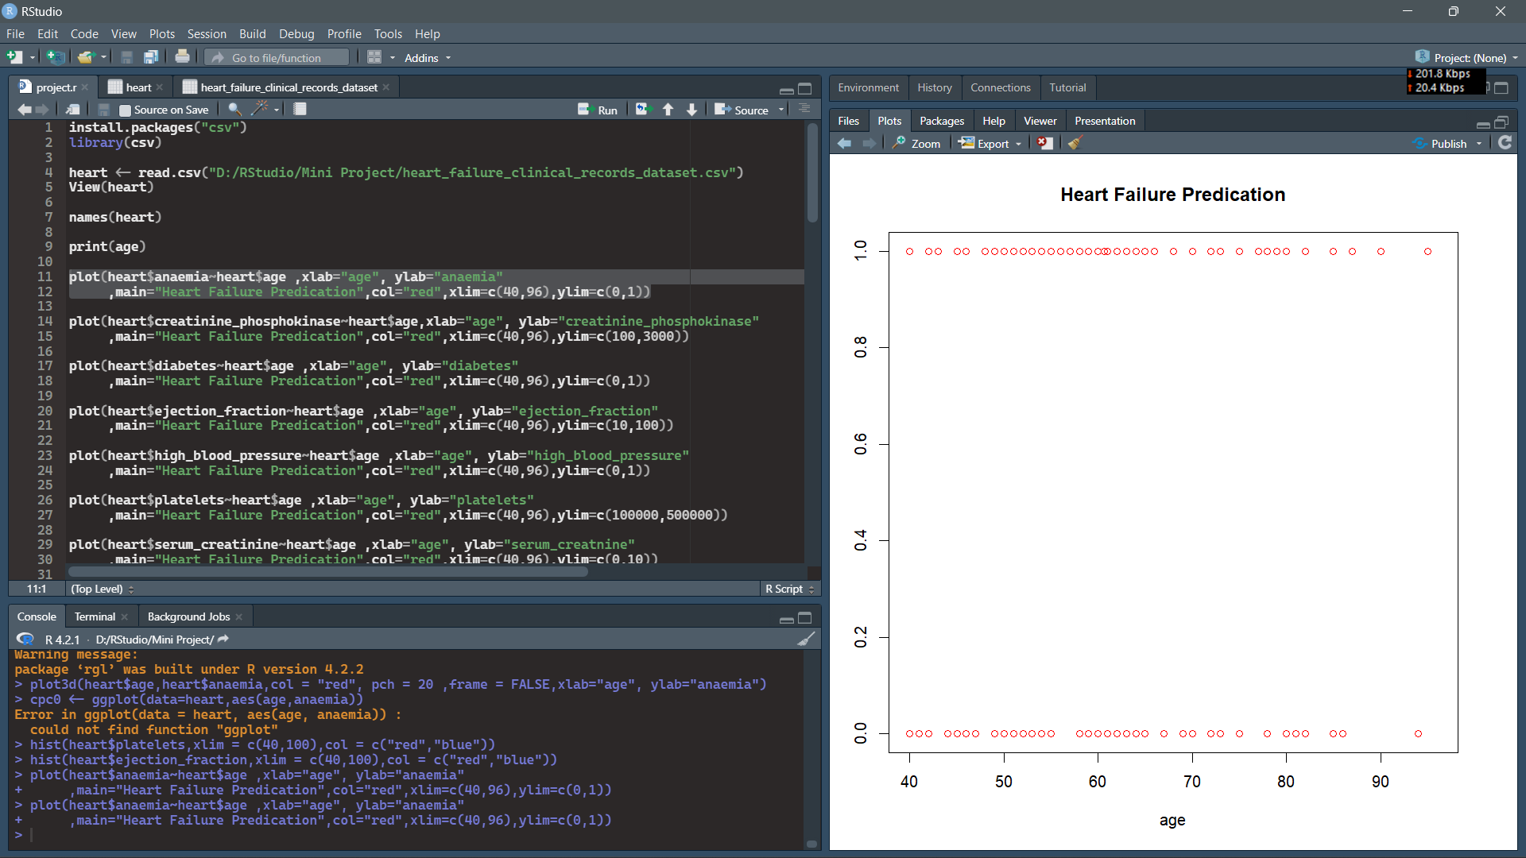

4. PLOT DIAGRAM(2) :

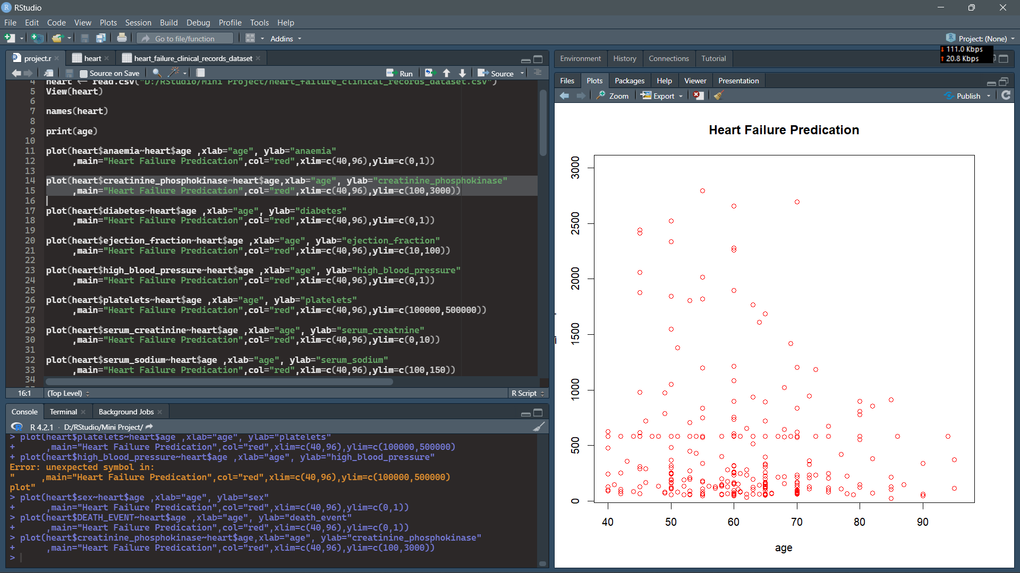

1. PLOT 3D DIAGRAM(1):

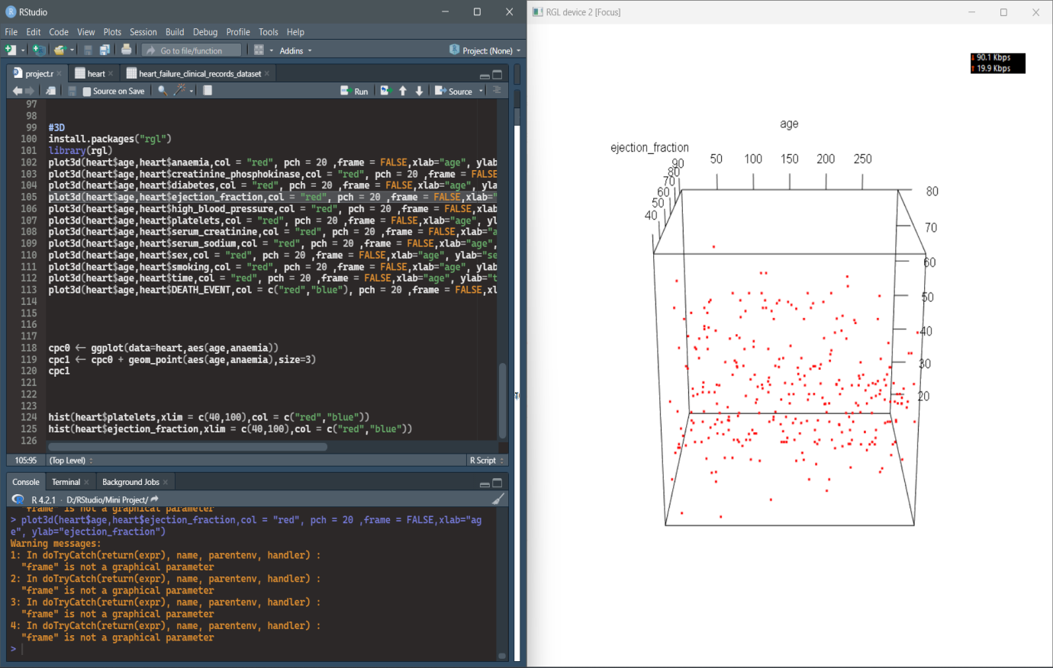

5. PLOT 3D DIAGRAM(2):

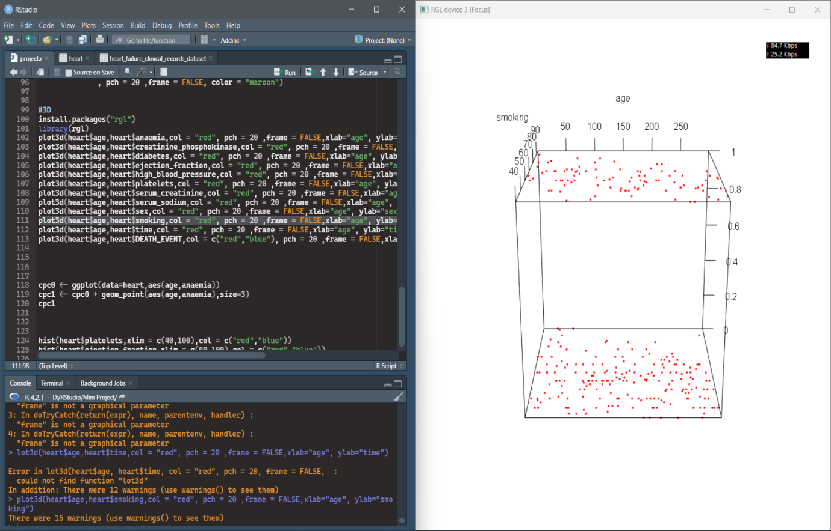

1. SCATTER PLOT(1):

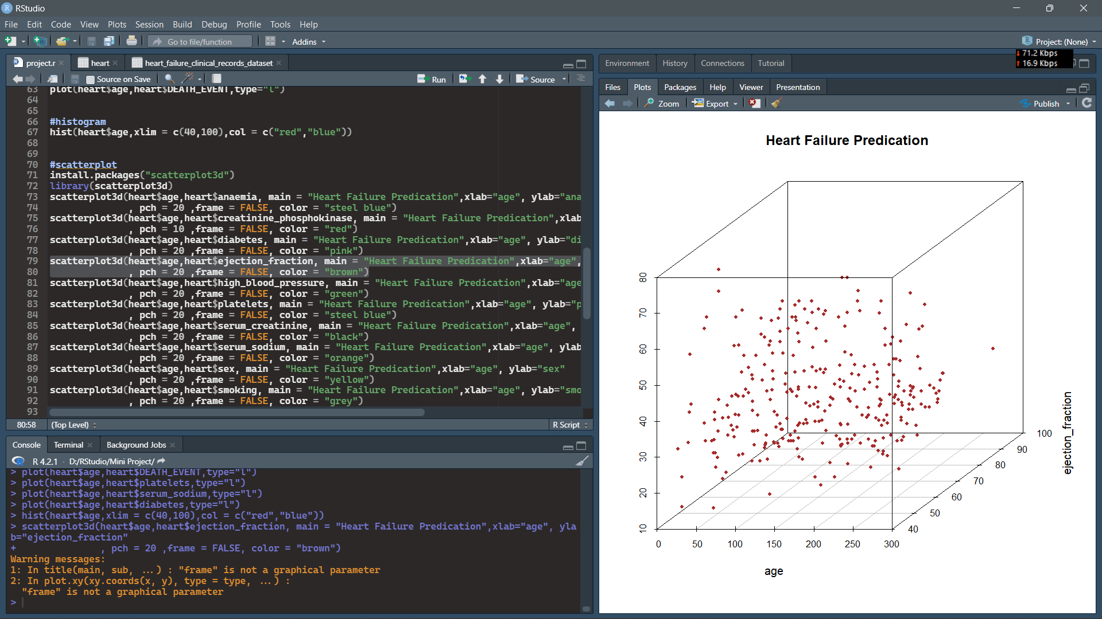

6. SCATTER PLOT(2):

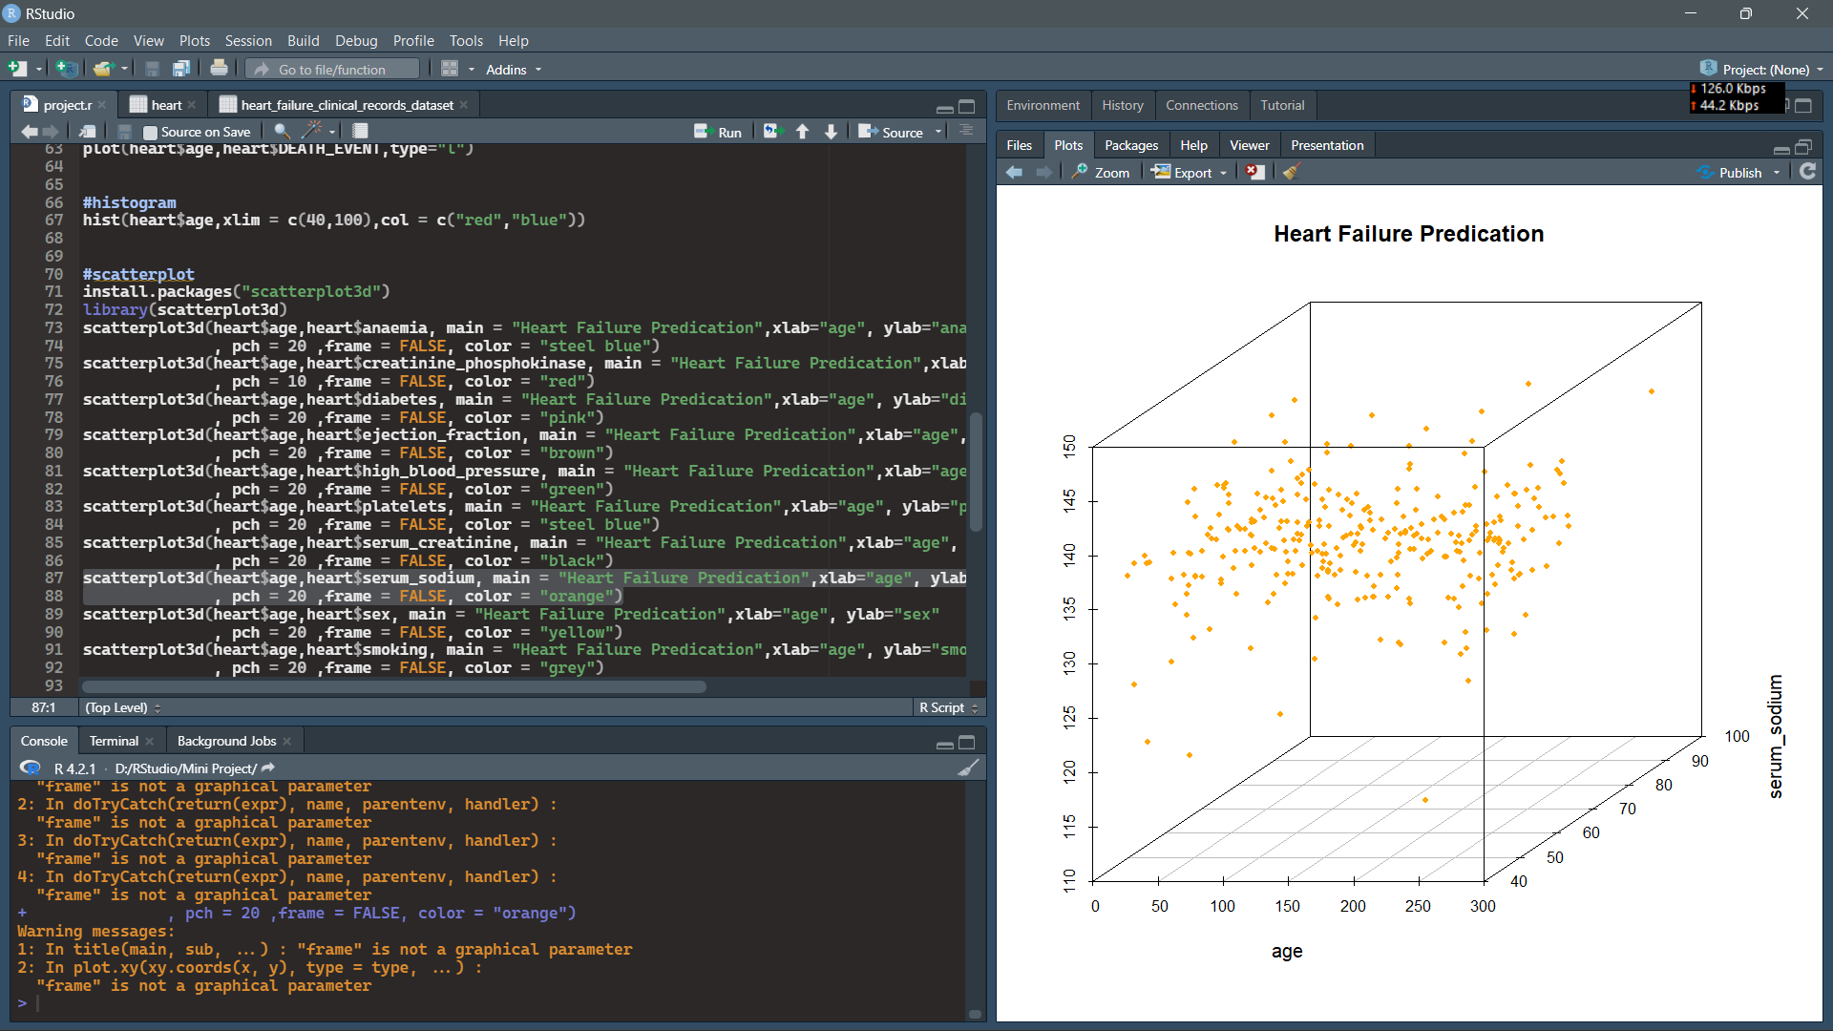

**CHAPTER 3 - USER MANUAL**

3.1 USER MANUAL

User simply needs to import the database and run the R script.

**CHAPTER 4 - CONCLUSION:**

During this analysis we selected ejection fraction and serum creatinine as the two most Relevant features confirming the heart failure. We can also use additional information to obtain more reliable results ( height, weight, body, mass) which is useful to detect additional risk factors for cardiovascular health diseases .

4.1 - LIMITATIONS AND DRAWBACKS :

Medical diagnosis is considered as a significant yet intricate task that needs to be carried out precisely and efficiently. The automation of the same would be highly beneficial. Clinical decisions are often made based on the doctor's intuition and experience rather than on the knowledge rich data hidden in the database. This practice leads to unwanted biases, errors and excessive medical costs which affects the quality of service provided to patients. Data mining has the potential to generate a knowledge-rich environment which can help to significantly improve the quality of clinical decisions.

4.2 - FUTURE ENHANCEMENT :

Here the scope of the project is that integration of clinical decision support with computer-based patient records could reduce medical errors, enhance patient safety, decrease unwanted practice variation, and improve patient outcome. This suggestion is promising as data modeling and analysis tools. Data mining has the potential to generate a knowledge-rich environment which can help to significantly improve the quality of clinical decisions.

4.3 - REFERENCES AND BIBLIOGRAPHY :

1)Kaggle:-<https://www.kaggle.com/datasets/andrewmvd/heart-failure-clinical-data>

2)A, A. S., & Naik, C. (2016). Different Data Mining Approaches for Predicting Heart Disease, 277–281. [https://doi.org/10.15680/IJIRSET.2016.050554](https://doi.org/10.15680/IJIRSET.2016.0505545)

3)Sai, P. P., & Reddy, C. (2017). International Journal of Computer Science and Mobile Computing HEART DISEASE PREDICTION USING ANN ALGORITHM IN DATA MINING. International Journal of Computer Science & Mobile Computing, 6(4), 168–172. Retrieved from [www.ijcsmc.com](http://www.ijcsmc.com)